Kol Simcha Torah Gazette
For parshas lech lecha 5787
Vol 11 Issue 6 (Whole #517) Cheshvan 13 5787/October 24, 2026
Printed L’illuy nishmas Nechama bas R’ Noach, a”h
For a free subscription, please forward your request to keren18@juno.com
Past emails can be found on the website ShabbosStories.com under Brooklyn Torah Gazette
The Hidden Test
Rabbi Chaim Rosenfeld


Rabbi Chaim Rosenfeld

This week, we’re introduced to Avraham Avinu, and especially to one of his greatest challenges: “Lech lecha mei’artzecha—Go forth from your land.”
Think about that. Hashem asks Avraham to leave everything—his home, his country, his family, his comfort—and venture into the unknown. Would you do that? Would you leave everything behind simply because G-d said so? It’s an extraordinary test of faith.
Chazal tell us that every person in life experiences ten tests, just like Avraham. Each of us, on our own level, will face defining moments and decisions that shape who we become. Avraham’s tests were monumental. Think about it. Would you bring your own child as an offering? Would you go to war to rescue your nephew, even if it might cost you your life? These were tremendous tests of courage and faith.
But then comes one that, at first glance, doesn’t seem so dramatic. Avraham finally arrives in Eretz Yisrael, the land G-d Himself promised him, and what happens? There’s famine. No food. Hunger everywhere. So, Avraham pivots and goes down to Egypt.
What exactly, though, was the test? He arrives in the land, there’s no food, and he leaves. Where’s the challenge in that?
Here’s the key: the test wasn’t about going down to Egypt; it was about how he responded when things didn’t go as planned.
Hashem tells him, “Go to the land I will show you,” and Avraham obeys. But when he gets there, the situation collapses. Most people would have cried out, “Hashem, what’s going on? You told me to come here; why is there famine? Why are You doing this to me?” That’s the test. Will you complain? Will you question? Or will you stay steadfast, trusting that there’s a reason beyond your understanding?
That is the essence of so many of life’s tests. It’s not about the big, dramatic moments, but how we respond when things don’t go smoothly.
Think about Bnei Yisrael in the desert. They traveled from place to place, and at each stop there was a new challenge—no water, no food, unbearable heat. What was the test? Not just survival; but their reaction. Would they complain? Would they despair? Or would they turn to Hashem calmly and say, “Please help us”?
Our tests in life don’t always arrive in the form of grand trials. Sometimes, they show up in the everyday moments. You’re about to fall asleep and realize you didn’t daven Maariv. That’s a test. You’re watching the game and a friend calls, “Let’s go to Rabbi Rosenfeld’s class.” That’s a test. Your mother calls and asks for a ride, and you’re thinking, “She could just take an Uber.” That’s a test. Life is full of these small, hidden tests. And the question is: how will you respond?
Let’s say you set out to do a mitzvah and suddenly hit traffic. You could get frustrated. “Why is this happening? Hashem must be against me!” Or you could take a breath and think, “If Hashem put me here, there’s a reason. This moment must be for my good.”
That calm acceptance, that willingness to trust, is itself a tremendous victory.
That’s what it means to pass a nisayon.
The Hebrew word nisayon doesn’t just mean “test,” like a biology exam. It comes from the word nes, a banner, something lifted high. Every time you respond to life’s challenges with faith and patience, you lift yourself higher. You raise your inner banner. So yes, Avraham’s famine was a test. Not because he had to suffer hunger, but because he had to decide how to interpret it; complaint or confidence, despair or faith.
Every one of us faces our own version of that test every day. Most of them go unrecorded. There won’t be headlines or fanfare. But between you and Hashem, you’ll know, you passed. You elevated yourself. And that’s what life is all about: facing challenges, rising above them, and becoming a little more like Avraham Avinu, the father of faith.
Because you are his child, and within you is the same greatness.
Reprinted from the Parshat Lech Lecha 5786 edition of the Anytime.com Newsletter.
The Uniqueness of the Birth and Upbringing of Isaac:
A Legacy for the Jewish People
From the Teachings of the Lubavitcher Rebbe
Rabbi Menachem Mendel Schneerson, Zt”l
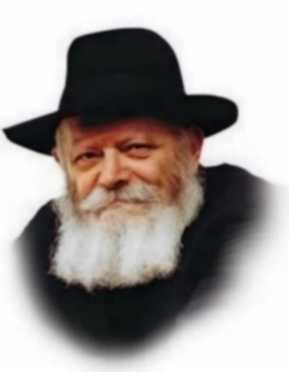
In this week's Torah portion, Lech Lecha, we are told about the births of Abraham's two sons, Ishmael and Isaac.

When G-d promised Abraham that he would have Isaac, Abraham already had a son, Ishmael. Thus, Abraham responded to G-d, "I pray that Ishmael might live before You" - i.e., that Ishmael would conduct himself as he should and pursue the Divine way of life. G-d, however, replied, "No. By Isaac shall your seed be called." From Isaac, Abraham was assured, his true joy would come.

There is a basic difference between Ishmael and Isaac. The birth of Ishmael was natural, without any heavenly intervention. Isaac's birth was miraculous for Abraham and Sara were far advanced in age.

Another difference between Ishmael and Isaac relates to the commandment of circumcision. Ishmael was circumcised when he was thirteen years old. At the age of thirteen a youngster has sufficient reason to be held accountable for his conduct and he becomes obligated to observe the mitzvot. Ishmael thus used his reason to determine his readiness to enter the covenant with G-d, and accepted circumcision.

Isaac was circumcised when he was eight days old. An infant that young cannot give consent; nevertheless, he was bound up with G-d at that early age. This type of bond can never be dissolved and erased; it is eternal, as the Torah calls it "an eternal covenant."

Isaac's supernatural and miraculous birth was in contrast to Ishmael's natural birth. And Isaac's covenant with G-d was in a supra-rational manner as opposed to Ishmael's covenant.

Normally a child is born and raised under the supervision of his parents, guarded against every harm. He is educated to gain proper understanding, which in turn leads to attachment with G-d. This was the way of Ishmael. He was raised in the home of Abraham and received an education which made him understand that he ought to attach himself to G-d.

This course of life, however, provides no assurances. When religious commitment is based exclusively on reason, we cannot predict how it will be affected by the variables of life. Thus, we find with Ishmael, that as soon as his inheritance was affected by Isaac's birth, his behavior deteriorated and G-d commanded Abraham to listen to Sara when she asked that Ishmael be sent away.

Lech Lecha teaches us that, to establish Jewish continuity, one cannot set out with strictly natural calculations. The very existence and purpose of the Jewish people transcends nature. A Jew's life, right from birth, is intertwined with miracles and a disregard for the course of nature.

Reprinted from the 2003/5764 Parashat Lech Lecha edition of L’Chaim, a weekly publication of the Lubavitch Youth Organization Excerpted from “Keeping in Touch by Rabbi Eliyahu Touger.

Rav Avigdor Miller on
The Test of Marriage

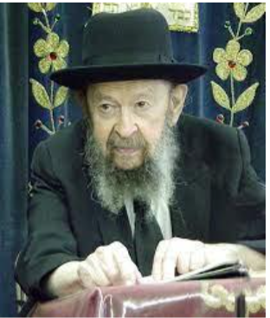

QUESTION: Why does a bas kol have to announce forty days before yetziras havalad who will marry whom?
ANSWER: Forty days before the child is created is the time to make plans for the nature and the character of that child. Some people are hot tempered. Some are cool. Some are lively. Some are quiet.
And so Hakadosh Baruch Hu is preparing a certain bride for a certain man. That’s what it means “forty days before.” Hakadosh Baruch Hu is preparing, because it’s so important to test a person in this world, and now He’s creating a lifelong mate for him, to test him. She tests him, and he tests her, and Hakadosh Baruch Hu knows each one perfectly, and so it’s made in order that each one should be tested fully.
After many years of living together he is kovesh his ka’as, and she is kovesh her tongue, and little by little they become better and better. לא טוב היות האדם לבדו – It’s not good for man to be by himself. With his wife he is constantly tested to become better and better, and she becomes better and better. And when their time is up, they go to Olam Haba, and they both get a tremendous reward.


But if they fail the test, chas veshalom, they have to know it’s a great tragedy, because he had an opportunity, and she had an opportunity. Because they were made to order for each other, in order to pass the test.
December 10, 1998

Reprinted from a recent email of Toras Avigdor based on a question asked to Rav Avigdor Miller in March 1996.

Thoughts that Count
For Our Parsha

The Torah Portion of Lech Lecha
Rabbi Shneur Zalman, the first Chabad Rebbe, said, "One must live with the time." His brother, R. Yehuda Leib, explained this to mean that one must live with the Torah portion of the week. One should not only learn the weekly portion every day, but live with it. A really joyous week is that of Lech Lecha. We live every day of the week with Abraham, the first to dedicate his very life to spreading G-dliness in the world. And Abraham bequeathed his self- sacrifice as an inheritance to all Jews. (Hayom Yom)

Go from your land (Gen. 12:1)
Ever since G-d told our father Abraham, "Go from your land etc," and subsequently "Avram kept travelling southward," we have the beginning of the mystery of birurim - elevating the sparks of holiness. By decree of Divine Providence man goes about his travels to the place where the "sparks" that he must purify await their redemption. The righteous tzadikim, who have vision, see where their birurim await them and go there deliberately. As for ordinary folk, The Cause of all Causes and the Prime Mover brings about various reasons and circumstances that bring these people to that place where lies their obligation to elevate the sparks. (Reb Shalom Dov Ber of Lubavitch)

Lech Lecha - Go from your land and your
birthplace and your father's house... (Gen. 12:1).
The literal translation of the words "Lech Lecha" is "Go to yourself." Going has the connotation in Torah of moving towards one's ultimate purpose - service towards one's Creator. And this is strongly hinted at by the phrase, "Go to yourself," meaning, towards your soul's essence and your ultimate purpose, that for which you were created. (Alshich as quoted by the Lubavitcher Rebbe)

Reprinted from the Parshat 5763/2003 (Issue #789) email of L’Chaim, a publication of the Lubavitch Youth Organization in Brooklyn, NY.

From Burned Trees to Mezuzot: How Kibbutz
Be’eri is Growing Again
By Michal Arieli

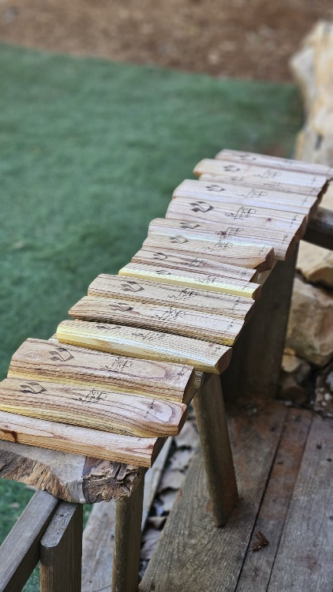

From trees scarred by war, a powerful symbol of new life is emerging. Discover the story of the 40 mezuzot being created for families returning to Be’eri.
The synagogue at Kibbutz Be’eri has witnessed its share of joyful occasions and, tragically, heartbreaking moments as well. It survived the terrorist attack on October 7th almost entirely intact and has since become a center for renewal, celebrations, and moving ceremonies.
Now, an extraordinary project is taking shape within its walls, transforming the scars of loss and destruction experienced by local residents into a symbol of rebirth.
Two people are behind the initiative: Tzviaz Kalchheim, a young wood artist and resident of Har Bracha, and Rachel Fricker, the synagogue’s gabbait in Be’eri. Together, they are creating 40 mezuzot from trees that were burned or damaged in the Gaza border area during the war.
“Everyone I tell about this project is moved to tears,” Rachel shares. “The thought of taking trunks and trees that fell, and turning them into mezuzot to hang at the entrances of the homes of people who chose to return to Be’eri and continue living after their homes were burned, it is unimaginable. It proves how the people of Israel continue to grow. Even when everything appears burned and broken, new life emerges from the great rupture.”

Growing Again
The idea for the mezuzot began to take shape at the start of the war.
“Like many others, I was called up to the war in the middle of Simchat Torah,” Tzviaz recalls. “My brigade was assigned to an area near Be’eri, so we passed through Be’eri and had contact with the kibbutz. From time to time, we went in to rest, and among other things, we prayed in the kibbutz synagogue.
“The first time I entered the synagogue, I saw an artistic mezuzah hanging by the entrance in the shape of a tree. The tree appeared to have been cut down, yet fresh branches were bursting forth from it, and beneath it were the words: ‘The people of Israel are connected to their roots and grow again.’
“Since I am an artist who carves Judaica items from rare woods, I was deeply impressed by the piece. It moved me so much that I told myself I had to create a set of mezuzot inspired by it.”
At the time, however, Tzviaz was busy fighting and could not begin the project. But between deployments, whenever he had a few free minutes, he found another way to create something meaningful.
“I carved a Torah pointer from one of the trees that had fallen in the area during military activity around Be’eri,” he explains. “It pained me to see the trees being thrown away, and since I have tried, from the start of my military service, to leave a Torah pointer at every military base where I serve, it felt natural to do so in Be’eri as well. Afterward, I left the place and did not even bother to check whether they had received the gift or what they did with it.”
That was when Rachel Fricker entered the story. When she discovered the pointer, she was deeply moved and wanted to know who had carved it. She filmed a video of herself receiving the unusual gift and said, “I don’t know who this is from, but if you see this video, we would love to meet you.”
At the time, Tzviaz was fighting, so he never saw the video and was unable to meet Rachel.
“We only met a year later,” he says.
“It was a special meeting,” Rachel adds. “The remarkable thing is that at exactly that time, we were about to complete the writing of a Torah scroll. It is a Torah scroll written by the entire people of Israel, and I felt that the right thing would be to use such a pointer for the reading. After all, there is nothing that demonstrates the eternity of the people of Israel more clearly.”
During their meeting, Tzviaz shared how deeply he had been affected by the mezuzah at the synagogue entrance and asked Rachel about the story behind it. As it turned out, she had a personal connection to its creator.
“The creator of the mezuzah was Shmuel Avni, of blessed memory,” Rachel explains. “He was one of the founders of Kibbutz Be’eri and served as regional council head for two terms. I met him when I worked as a nurse in a nursing home, and I was with him in his final days before he passed away. We had deep conversations about life, and on that occasion he also showed me the mezuzah he had created.
“Then he surprised me by personally asking me to give him the opportunity to put on tefillin. It was the first time in his life that he had put on tefillin. I was so emotional that I did not even take a photo. This is the man behind the creation of the mezuzah.”
By then, Tzviaz had no doubt that he wanted to create a series of mezuzot inspired by Shmuel Avni’s original design. When he shared the idea with Rachel, another thought emerged: Why not give the mezuzot to residents returning to homes being rebuilt in the kibbutz?
“It moved me so deeply,” Rachel says. “Two new neighborhoods are being built in our kibbutz, and right now, residents evacuated from their burned homes are preparing to move into them. This is an incredible, special gift with so much meaning.”
Because the project required funding, Rachel approached Rabbi Shlomo Raanan of the Ayelet HaShachar organization. He helped fund 40 mezuzot, on one condition: that they include the words, “And I said to you: In your blood, live.”

Blood, Life, and Renewal
Tzviaz got to work bringing the vision to life.
“I deliberated over how the mezuzot should be designed,” he recalls. “It was important to me to incorporate the required verse, but I also wanted to build on the design of the original mezuzah. In the end, I took the branch from the original design and turned it into a plant flowering out of the Hebrew letter lamed. I also enlarged the word ‘live,’ creating a mezuzah with the requested inscription.
“I felt it was a winning combination. On one hand, blood and pain; on the other, life, flowering, and renewal, without ignoring the difficulty the people of Israel are going through.”

Where did you get the wood for the mezuzot?
“Here I received great help from Heaven, because as I mentioned, the idea was to make the mezuzot specifically from trees that fell in the Gaza border area. When I tried to figure out how to do this, I discovered that some trees are set aside especially for artists rather than being thrown away. So far, I have designed 20 mezuzot, and I intend to continue until the project is complete, with Hashem’s help.”

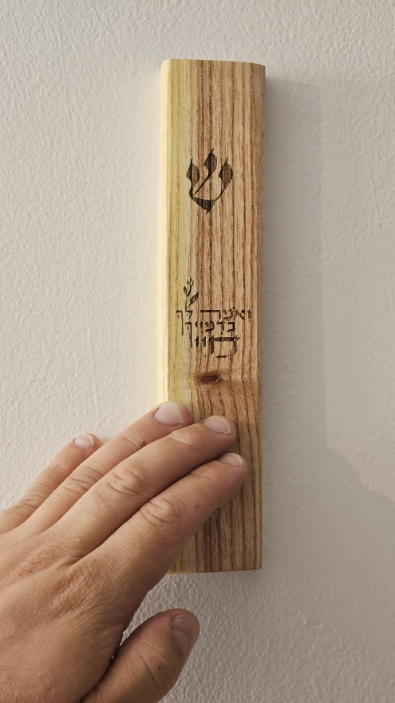

Isn’t it difficult to work with trees that fell under such tragic circumstances?
“Some people hear that I use trees from the Gaza border area and ask me, ‘How can you?’ My approach is the complete opposite. It is known that the Ben Ish Chai hung a stone from the Land of Israel beside the mezuzah at the entrance to his home in Baghdad, explaining that he did so so that Baghdad’s Jews would kiss the Land of Israel along with the mezuzah.
“I can say for myself that I make the Judaica items I carve exclusively from trees from Israel. I do not order wood from AliExpress or from other unknown places. My goal is exactly like that of the Ben Ish Chai: that people kiss the mezuzah and love the land. As it is said: ‘For Your servants have cherished her stones and favored her dust.’
“Now, when the mezuzot are designed in a way that connects us to our roots, it completes the message in my eyes and closes the circle. It shows us exactly what Shmuel Avni wrote on the mezuzah: the people of Israel are growing again, and the roots remain planted deep in the ground.”

Reprinted from the website of Hidabroot.com
What You Need to Know About Visiting the Zoo
By Yehuda Shurpin

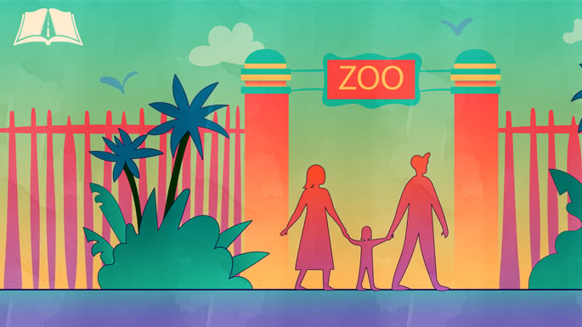
Art by Sefira Lightstone

A visit to the zoo can be more than just an enjoyable outing; it is also an opportunity to reflect on the wonders of G-d’s creation.

Great Rabbis Going to See G-d’s Creations
Rabbi Yisrael Isserlin (1390–1460), a leading halachic authority in 15th-century Europe, records traveling to see two lions that had been brought to a nearby city for display, his first time seeing a lion.¹
Similarly, Rabbi Chaim Yosef David Azulai (1724–1806), known as the Chida, a renowned rabbi, halachic authority, and traveler who visited Jewish communities throughout Europe and the Mediterranean, records seeing various animals during his travels, reflecting his curiosity about the natural world and his appreciation for the wonders of G-d’s creation.²
At the same time, it raises several practical halachic questions: Which animals warrant a special blessing? Are there guidelines about looking at non-kosher animals? And may you feed the animals on Passover? Here is a look at some of the relevant Jewish laws.
Making a Blessing When Visiting the Zoo
The Talmud teaches that when you see an elephant or monkey (and a “kefof”³), you recite the blessing Meshaneh Habriyot, praising G-d, “Who varies the forms of the created beings.”⁴
There is a dispute regarding how often the blessing may be recited. The Code of Jewish Law rules that it is said only once in a lifetime for each type of animal,⁵ while Rabbi Moshe Isserlis, the Rama, rules in his gloss that it may be said anytime as long as you haven’t seen one in the past 30 days.⁶
Practically, according to Rabbi Schneur Zalman of Liadi, the Alter Rebbe, one makes the blessing once in a lifetime for each species.⁷ Thus, once you have recited Meshaneh Habriyot upon seeing an elephant, you would not recite the blessing again upon seeing another elephant, even years later, but would still recite it the first time you see a monkey. There is also a discussion whether Meshaneh Habriyot applies only to elephants and monkeys, which the Talmud specifically mentions, or to all uniquely unusual looking animals.
Some authorities maintain that the blessing applies only to elephants and monkeys,⁸ citing various reasons for why these animals would be singled out. Among the explanations is that the monkey has some features and characteristics similar to humans, and the elephant is notably strong and smart, as well as large.⁹ Another fascinating explanation is that, according to some, after the incident with the Tower of Babel, G-d turned some people into apes and elephants.¹⁰
Others extend the blessing to other remarkably unusual creatures.¹¹ The Alter Rebbe omits any mention of monkeys or elephants in the context of this blessing; this would indicate that he believes that this blessing is recited on other uniquely remarkable creatures as well.

Children and Non-Kosher Animals
Although strictly speaking there is no halachic prohibition against looking at non-kosher animals (or pictures of them), the Kav Hayashar and others emphasize the importance of guarding one’s eyes from devarim temei’im (impure things or creatures).¹² The Rebbe strongly emphasized this with regard to young children, whose impressions are especially formative, and encouraged training them to focus their eyes on positive and holy things.¹³
This does not, however, mean that children may never see non-kosher animals. For example, one may visit a zoo to appreciate the wonders of G-d’s creation. Likewise, animal pictures may be used for educational purposes, and one may surely look at unusual animals when necessary to recite Meshaneh Habriyot.¹⁴
Some sources indicate that pregnant women should be more careful about looking at non-kosher animals. Accordingly, some are extra particular about not visiting a zoo during pregnancy.¹⁵ Others write that even a pregnant woman can visit for an appropriate purpose while avoiding intentionally gazing at the non-kosher animals (a slight glance would not count).¹⁶

Animals Mating
While much of the above discussion is beyond the letter of the law, it should be noted that there is a separate prohibition against gazing at animals or birds while they are mating,¹⁷ which seemingly extends to watching videos of them mating as well.

Feeding Animals at a Zoo on Passover
It is forbidden to derive benefit from chametz on Passover. Therefore, even if you do not own the chametz—for example, if someone gives it to you for free—it is prohibited to feed it to an animal.
This is relevant when visiting a traditional zoo, petting zoo, or farm, where the animal and bird feed provided to visitors is often made with chametz ingredients. Unless you have verified that the food is chametz-free, you should not feed it to the animals on Passover, whether you purchase the food or receive it for free.
Even if the food is already lying on the ground, you should not pick it up and throw it into the animal’s enclosure.
Parents should explain this to their children before visiting a zoo or petting zoo during Passover.

Footnotes
1. Leket Yosher, Hilchot Melachot Shabbat (pg. 142 in the Machon Yerushlayim ed.). 2. See, for example, his Ma’agal Tov, Jerusalem 1934, pp. 5, 68, 32, 68, 69; Midbar Kedeimot, 2:22. 3. There are differences of opinion as to what sort of creature this refers to, some translate it as an owl. 4. Talmud Berachot 58b.
5. Shulchan Aruch, Orach Chaim 225:8-9. 6. Rama, Shulchan Aruch, Orach Chaim 225:9. 7. Seder Birkat Hanehnin 13:13. 8. See Piskei Teshuvot 225:21; See also Shaar Ha’ayin, ch. 15, fn. 18, quoting Rabbi Elyashiv and Rabbi Kanievsky.
9. See, for example, Meiri on Talmud Berachot 58b; Rabbi Yaakov Emden, Mor Uketziah, 225. 10. See, for example, commentary Melechet Shlomo on Mishnayot Kilayim 8:6. See also Mayim Rabim - Birchat Haraiyah, 12:7, fn. 29, for various other sources that discuss this. 11. See, for example, Halichot Shlomo, Hilchot Tefilah Uberochot 23:35. 12. See Kav Hayashar, ch. 2. 13. See Talk by the Rebbe, 20th of Cheshvan, 5744 (1983), printed in Likkutei Sichot vol. 25, pg. 309.
14. See, for example, Likkutei Sichot vol. 25 pg. 309 fn. 2 and 5. 15.See, for example, Torat Menachem 5750, vol. 3, p. 179; Ma’avar Yabok, Ma’amar Sefatei Tzedek, ch. 5; Shevet Mussar, ch. 24. 16. See Shevach Habrit, p. 25, fn. 17, and Rabbi Braun here, who explain that it isn’t clear that there was any specific directive regarding pregnant women being careful about visiting a zoo even when it meets the above criteria. 18. Talmud Avoda Zarah 20b; Shulchan Aruch, Even Haezer 23:3.

Reprinting from the website of Chabad.Org

